How to create a basic Hello world Using node express js.?

*Contents*

*Installation* 1

*Step1* 1

*Step 2:* 2

*Step 3:* 2

*Step-4:* 3

***Code:*** 4

***Exercises*** 5

*Installation****:***

*Step1:*

*First you need to install node js ,*

*Download here :* [*https://nodejs.org/en/download/*](https://nodejs.org/en/download/)

*If you have already installed then ignore it.*

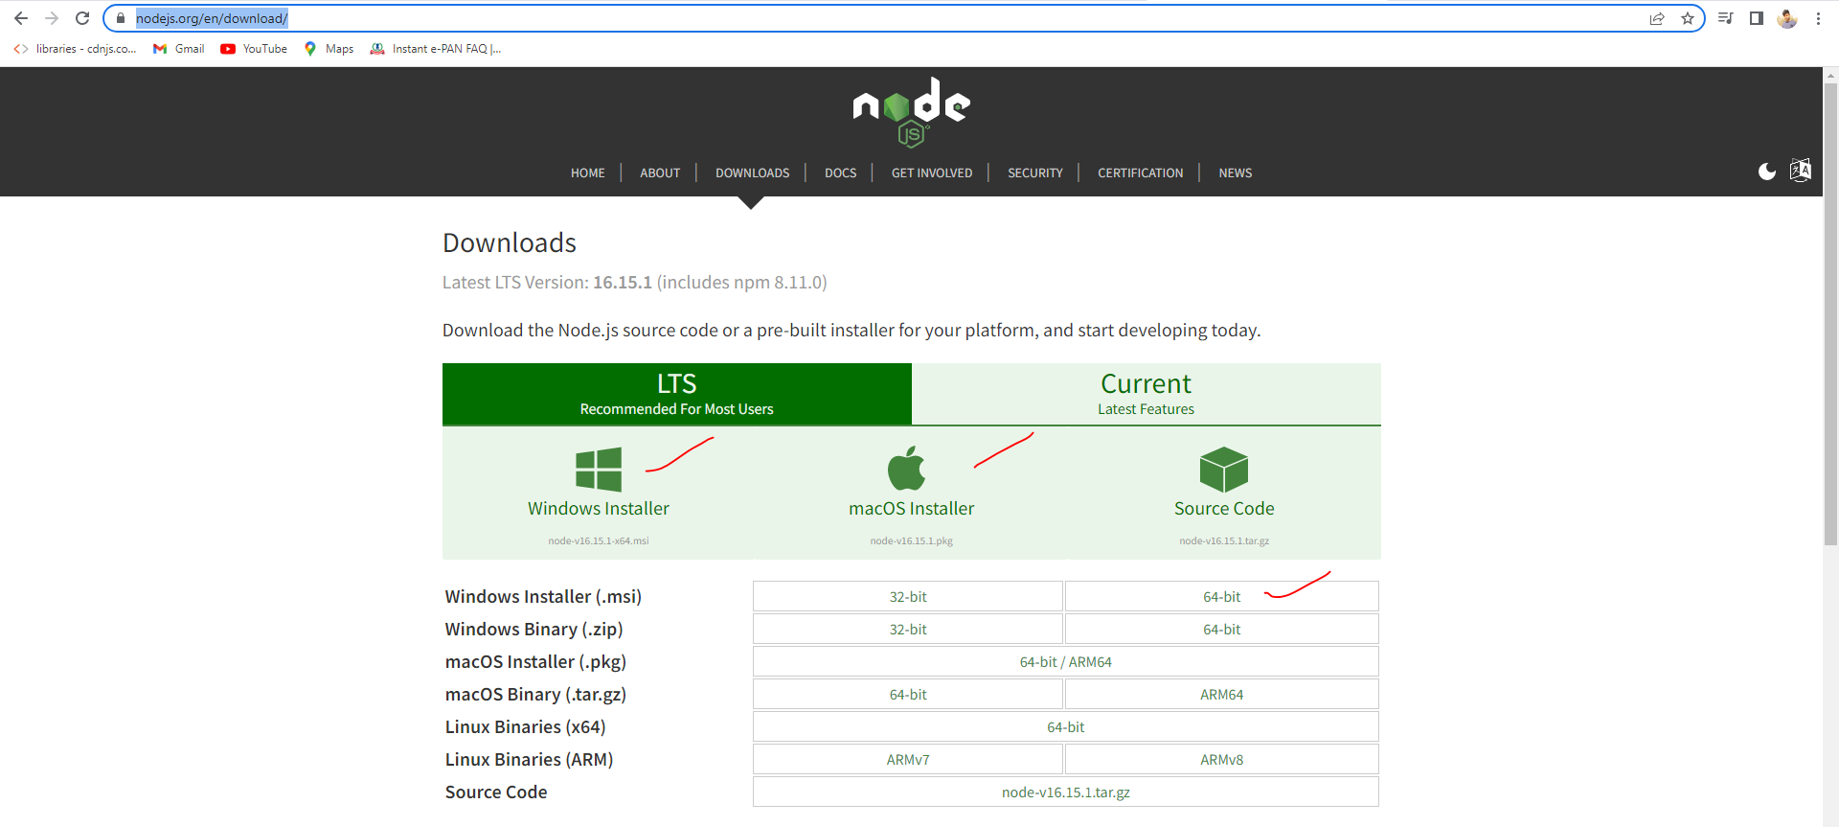

*After installation process done plesase check the below commands in your terminal.*

*Check the versions node -v, npm -v*

## *Step 2:*

*Create a folder and open that folder in terminal*

*Pic-1:*

*Create a folder name ‘NodeCrudOperation’ and select all the path and type 'cmd' see the below images*

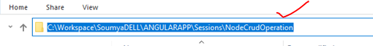

*Pic-2:*



*Pic-3:*

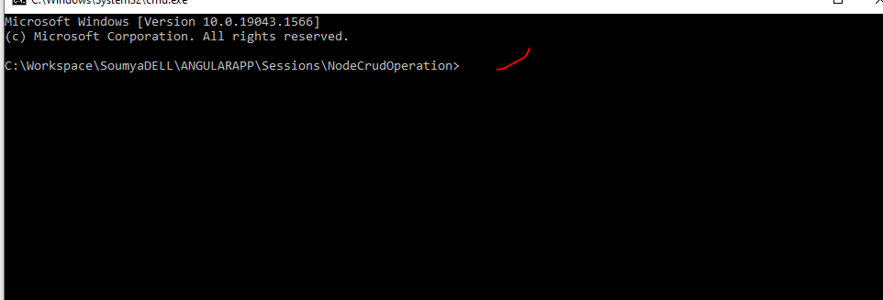

## *Step 3:*

*Run this command `npm init`. This will create package json. See the below image*

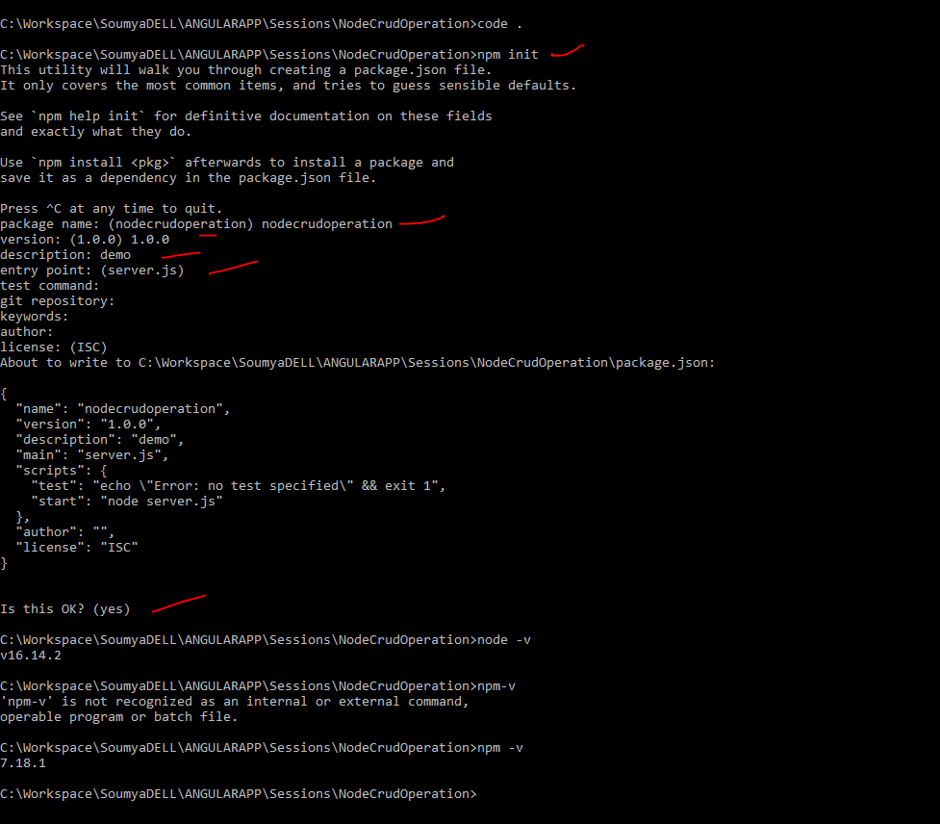

## *Step-4:*

*Create a .js file (server.js) file.(You can give your own file name) and run this command on your terminal” npm install express”*

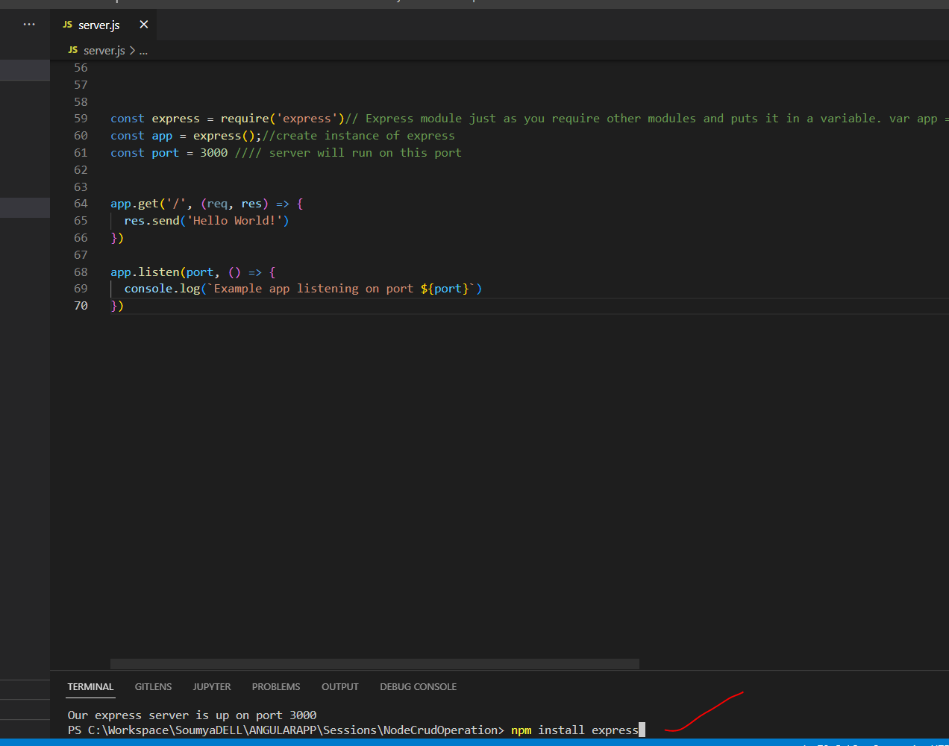

# ***Code:***

*Write below code inside server.js*

*const express = require('express')// Express module just as you require other modules and puts it in a variable. var app = express(); => Calls the express function "express()" and puts new Express application inside the app variable (to start a new Express application)*

*const app = express();//create instance of express*

*const port = 3000 // server will run on this port*

*app.get('/', (req, res) => {*

*res.send('Hello World!')*

*})*

*app.listen(port, () => {*

*console.log(`Example app listening on port ${port}`)*

*})*

*Image:*

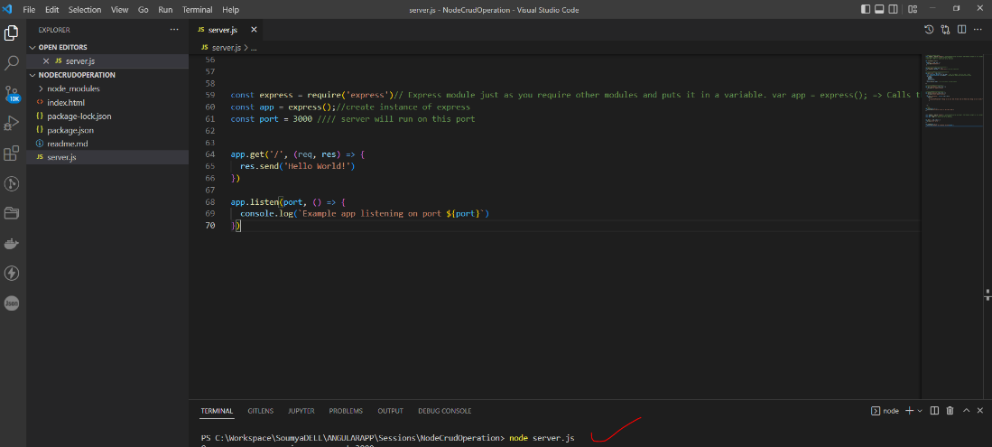

*After writing code then open your terminal and run this command ‘****node server.js****’.*

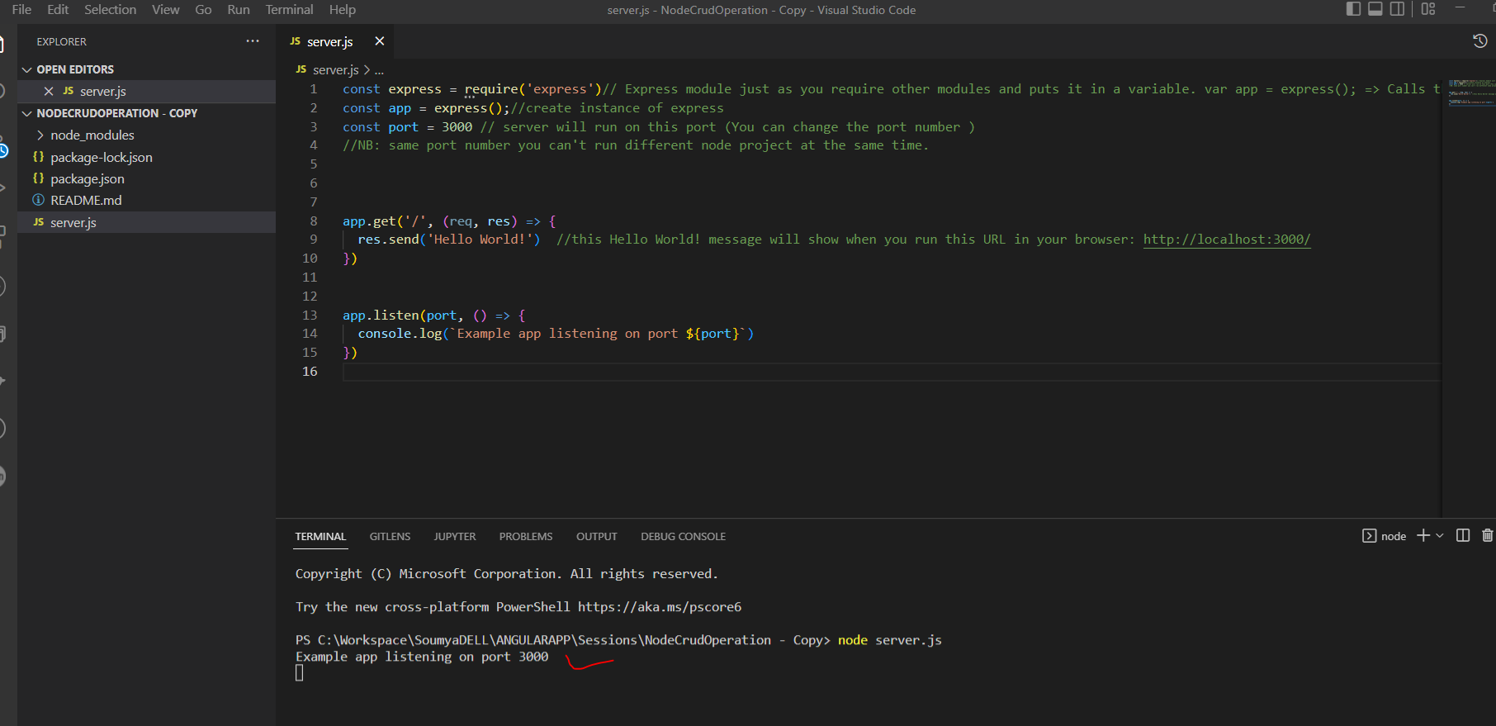

*Output:*

*http://localhost:3000/*

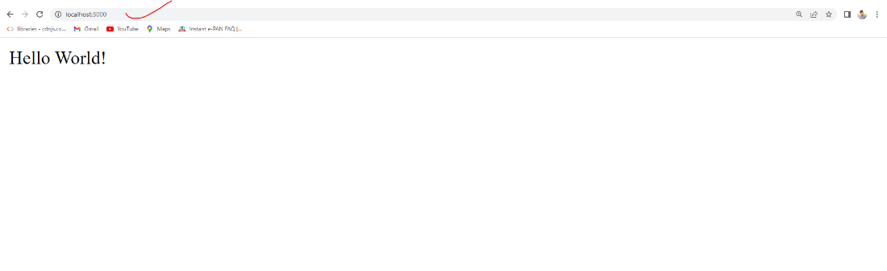

***Exercises:***

*Q1.* create a node js GET api send "Hi this is my first program " .using this url http://localhost:3000/user/something

check the router Path.

*Q2.*

***Short Key:***

*In a specific folder command prompt Type Code . (code space dot) it will open your project directly in vs code.*

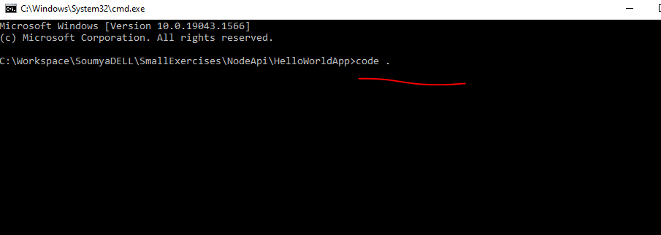

*Ctrl+shift+c : when your project is open on vs code then type Ctrl+shift+c at a time then command prompt will open directly.*

